**Test data for Postman:**

**Methods**

**Method Type: GET**

* Get Gateway by serial number: <http://localhost:5001/api/gateways/c9d4c053-49b6-410c-bc78-2d54a9991870>
* Get Gateway by serial number (Gateway doesn’t exist): <http://localhost:5001/api/gateways/c9d4c053-49b6-410c-bc78-2d54a9991877>
* Get all Gateways(paging): <http://localhost:5001/api/gateways/pag?pageNumber=1&pageSize=2>
* Get all devices for a Gateway: <http://localhost:5001/api/gateways/c9d4c053-49b6-410c-bc78-2d54a9991870/devices>
* Get Device for UID: <http://localhost:5001/api/gateways/c9d4c053-49b6-410c-bc78-2d54a9991870/devices/6>
* Get Device for UID (It doesn’t exist): <http://localhost:5001/api/gateways/c9d4c053-49b6-410c-bc78-2d54a9991870/devices/5>

**Method Type: POST**

* Create Gateway: <http://localhost:5001/api/gateways>

*Body*

{

    "name": "Gateway33",

    "iPv4Address": "10.8.73.25",

    "devices": **null**

}

*Body with invalid IPv4*

{

    "name": "Gateway5",

    "iPv4Address": "10.8.77.",

    "devices": **null**

}

* Create Device: <http://localhost:5001/api/gateways/c9d4c053-49b6-410c-bc78-2d54a9991870/devices>

*Body*

{

    "vendor": "Exp KL09",

    "dateCreated":"2022-08-02T00:00:00",

    "status": **true**

}

**Method Type: DELETE**

* Delete Gateway with its devices: [http://localhost:5001/api/gateways/ c9d4c053-49b6-410c-bc78-2d54a9991845](http://localhost:5001/api/gateways/%20c9d4c053-49b6-410c-bc78-2d54a9991845)
* Delete Gateway with its devices (gateway doesn’t exist): [http://localhost:5001/api/gateways/ c9d4c053-49b6-410c-bc78-2d54a9991845](http://localhost:5001/api/gateways/%20c9d4c053-49b6-410c-bc78-2d54a9991845)
* Delete Device: <http://localhost:5001/api/gateways/c9d4c053-49b6-410c-bc78-2d54a9991870/devices/2>
* Delete Device (it’s doesn’t exist): <http://localhost:5001/api/gateways/c9d4c053-49b6-410c-bc78-2d54a9991870/devices/5>

**Method Type: PUT**

* Update Device: <http://localhost:5001/api/gateways/c9d4c053-49b6-410c-bc78-2d54a9991870/devices/8>

*Body*

{

"vendor": "Modem-08X",

"dateCreated": "2022-08-07T00:00:00",

"status": **false**

 }

* Update Device (gateway doesn’t exist): <http://localhost:5001/api/gateways/c9d4c053-49b6-410c-bc78-2d54a9991830/devices/8>
* Update Device (device doesn’t exist): <http://localhost:5001/api/gateways/c9d4c053-49b6-410c-bc78-2d54a9991830/devices/90>
* Update Gateway: <http://localhost:5001/api/gateways/8255F798-F6F8-4447-FAC3-08DA7A32EEDE>

{

  "name": "Gateway1",

  "iPv4Address": "10.8.77.120",

  "devices":null

 }

* Update Gateway (Gateway doesn’t exist): <http://localhost:5001/api/gateways/00C0D27E-9032-4A58-87F1-08DA7B20E1E7>

**Method Type(examples): GET**

**Get Gateway by serial number:** <http://localhost:5001/api/gateways/c9d4c053-49b6-410c-bc78-2d54a9991870>

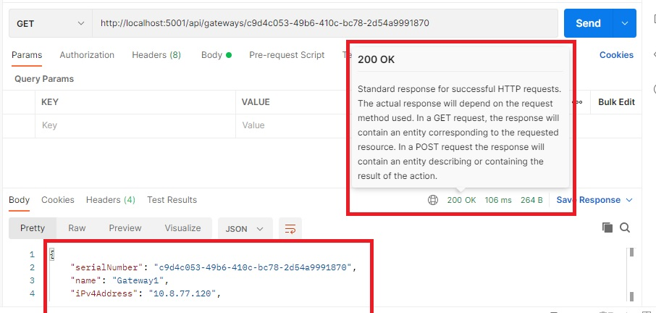

**Get Gateway by serial number (Gateway doesn’t exist):** http://localhost:5001/api/gateways/c9d4c053-49b6-410c-bc78-2d54a9991877

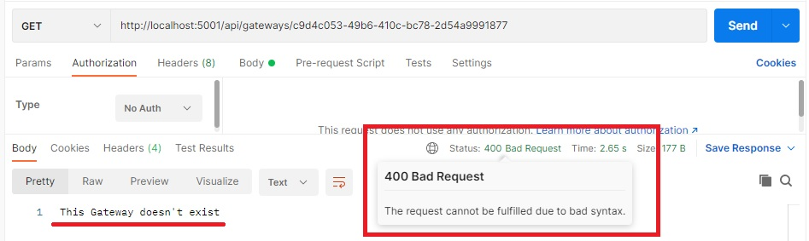

**Get all Gateways:** <http://localhost:5001/api/gateways/pag?pageNumber=1&pageSize=2>

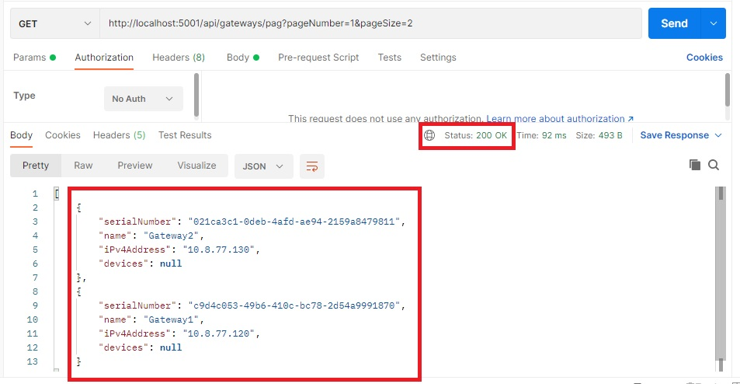

**Get all devices for a Gateway:** <http://localhost:5001/api/gateways/c9d4c053-49b6-410c-bc78-2d54a9991870/devices>

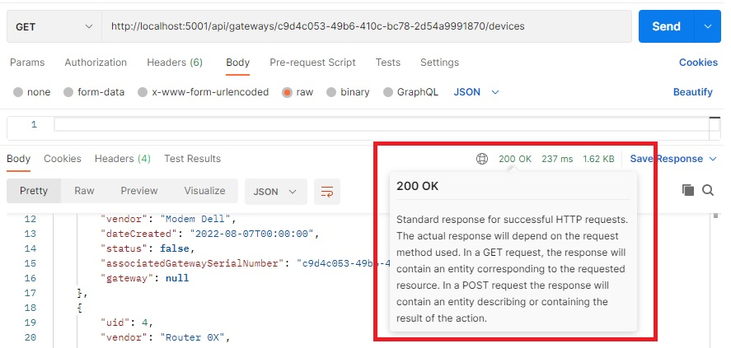

**Get Device for UID:** <http://localhost:5001/api/gateways/c9d4c053-49b6-410c-bc78-2d54a9991870/devices/6>

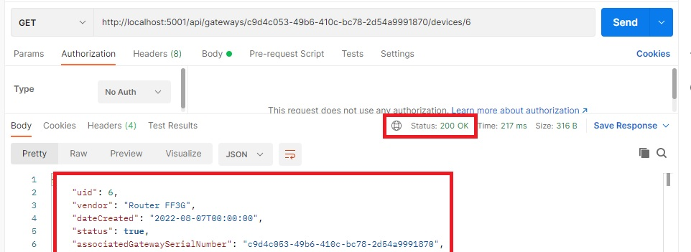

**Get Device for UID (It doesn’t exist):** <http://localhost:5001/api/gateways/c9d4c053-49b6-410c-bc78-2d54a9991870/devices/5>

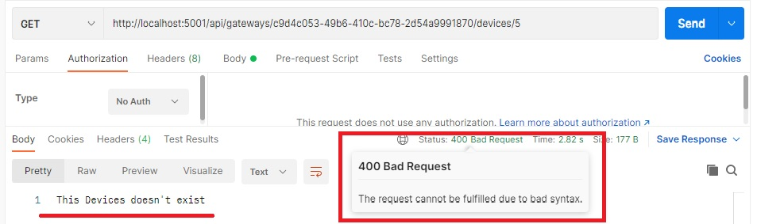

**Method Type(examples): POST**

**Create Gateway:** <http://localhost:5001/api/gateways>

*Body*

{

    "name": "Gateway33",

    "iPv4Address": "10.8.73.25",

    "devices": **null**

}

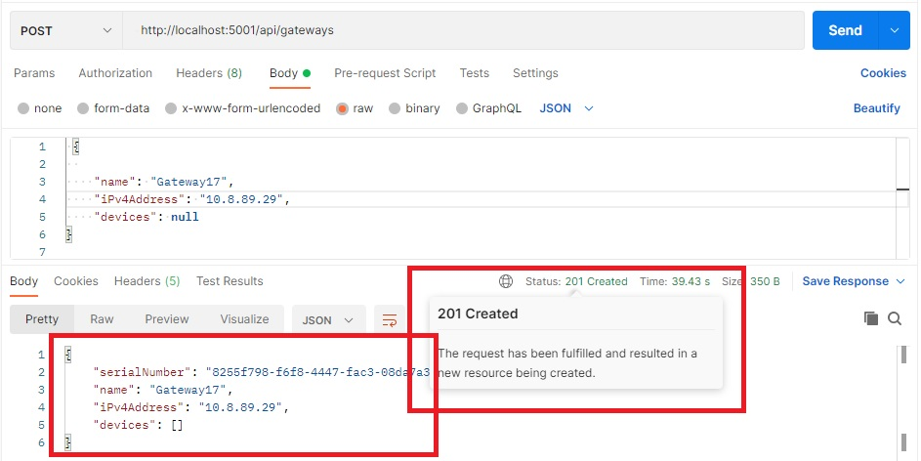

Body with invalid IPv4

{

    "name": "Gateway5",

    "iPv4Address": "10.8.77.",

    "devices": **null**

}

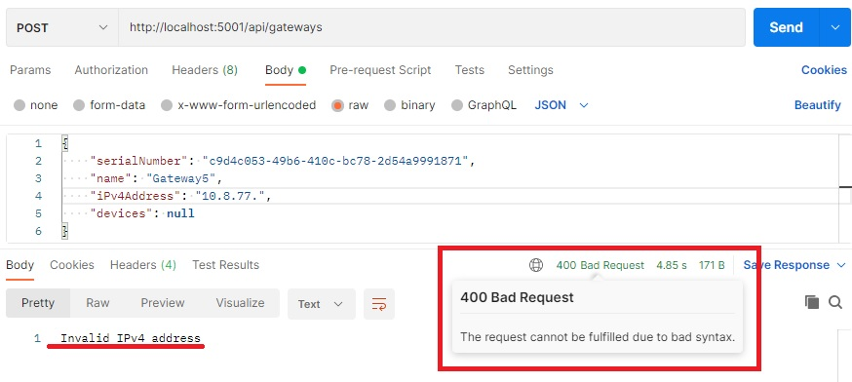

**Create Device:** <http://localhost:5001/api/gateways/c9d4c053-49b6-410c-bc78-2d54a9991870/devices>

*Body*

{

    "vendor": "Exp KL09",

    "dateCreated":"2022-08-02T00:00:00",

    "status": **true**

}

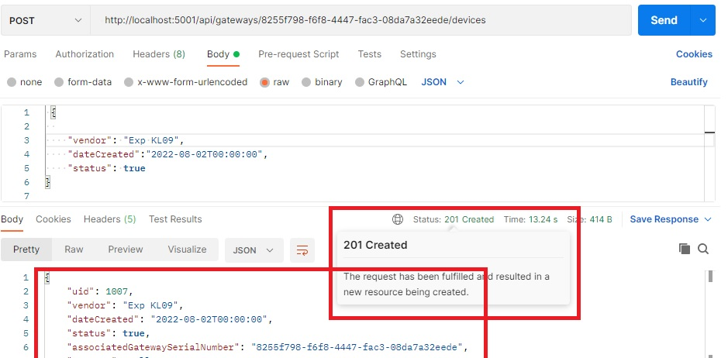

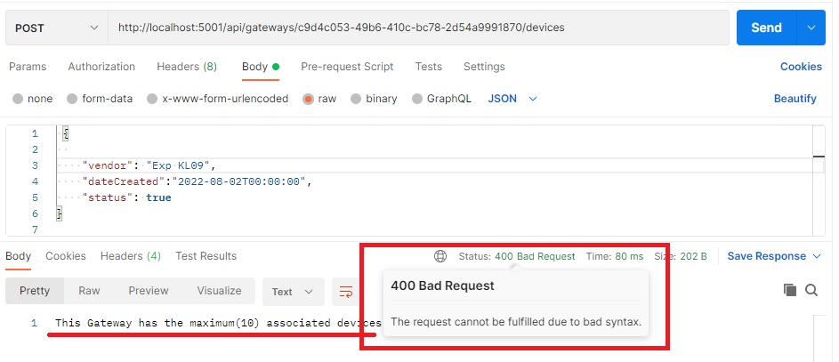

**Method Type(examples): DELETE**

**Delete Gateway with its devices:** [http://localhost:5001/api/gateways/ c9d4c053-49b6-410c-bc78-2d54a9991845](http://localhost:5001/api/gateways/%20c9d4c053-49b6-410c-bc78-2d54a9991845)

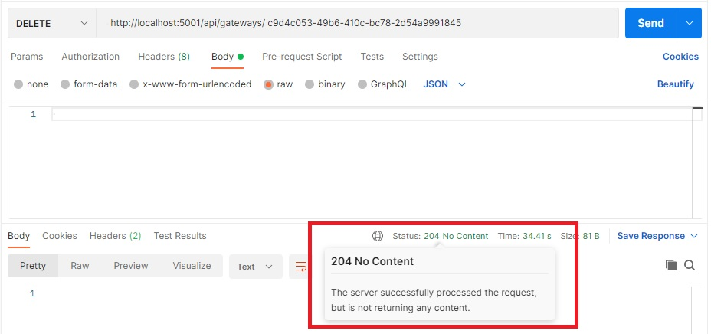

**Delete Gateway with its devices (gateway doesn’t exist):** [http://localhost:5001/api/gateways/ c9d4c053-49b6-410c-bc78-2d54a9991845](http://localhost:5001/api/gateways/%20c9d4c053-49b6-410c-bc78-2d54a9991845)

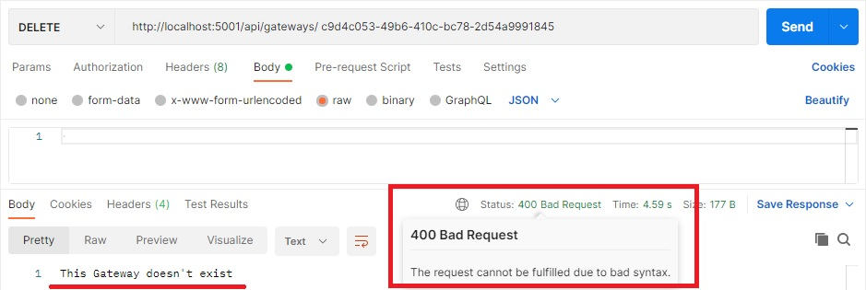

**Delete Device:** <http://localhost:5001/api/gateways/c9d4c053-49b6-410c-bc78-2d54a9991870/devices/2>

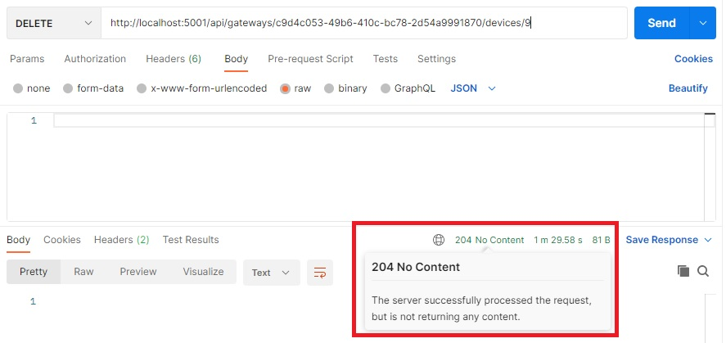

**Delete Device (it’s doesn’t exist):** <http://localhost:5001/api/gateways/c9d4c053-49b6-410c-bc78-2d54a9991870/devices/5>

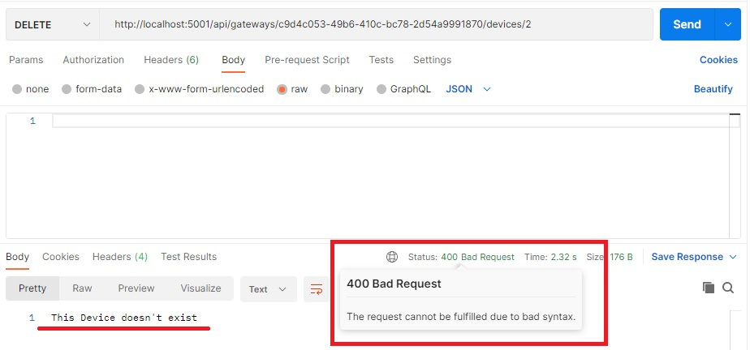

**Method Type(examples): PUT**

**Update Device:** <http://localhost:5001/api/gateways/c9d4c053-49b6-410c-bc78-2d54a9991870/devices/8>

*Body*

{

"vendor": "Modem-08X",

"dateCreated": "2022-08-07T00:00:00",

"status": **false**

 }

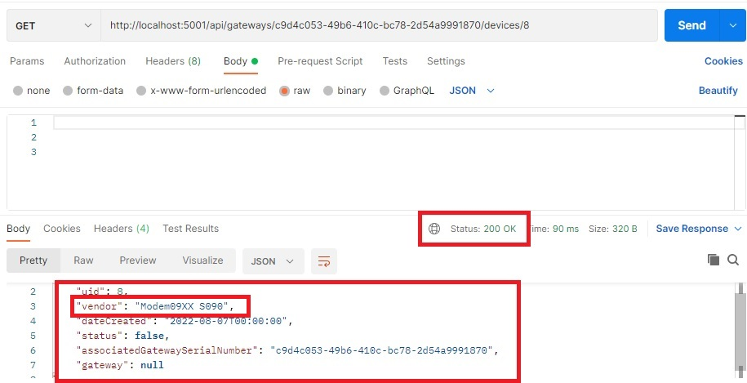

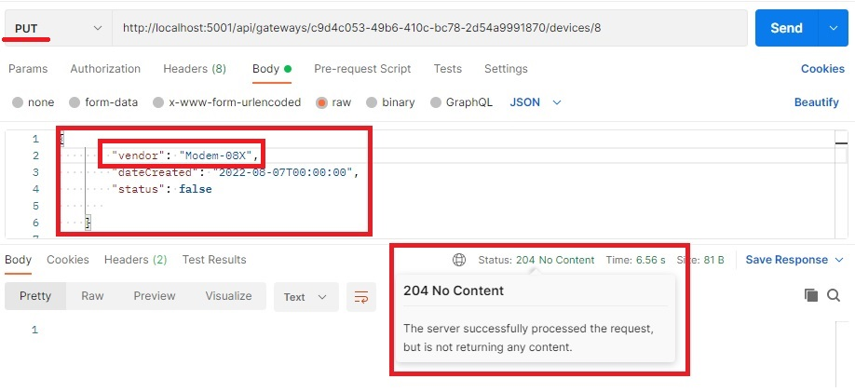

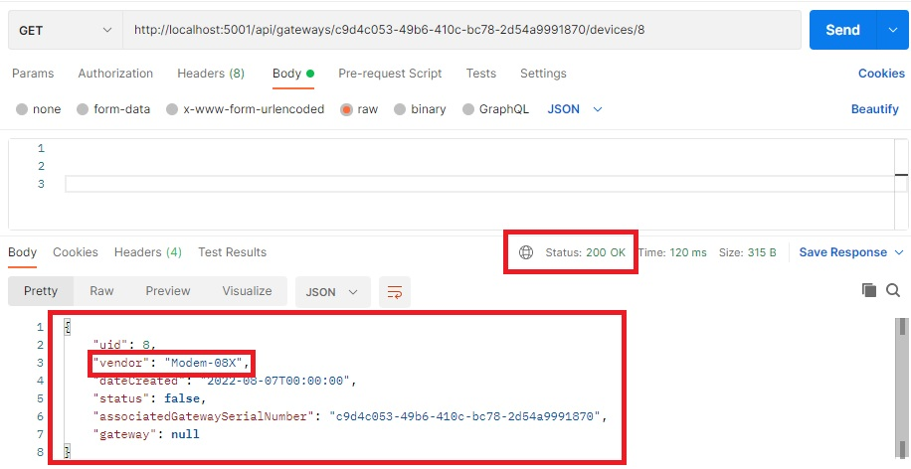

**Update Device (gateway doesn’t exist):** <http://localhost:5001/api/gateways/c9d4c053-49b6-410c-bc78-2d54a9991830/devices/8>

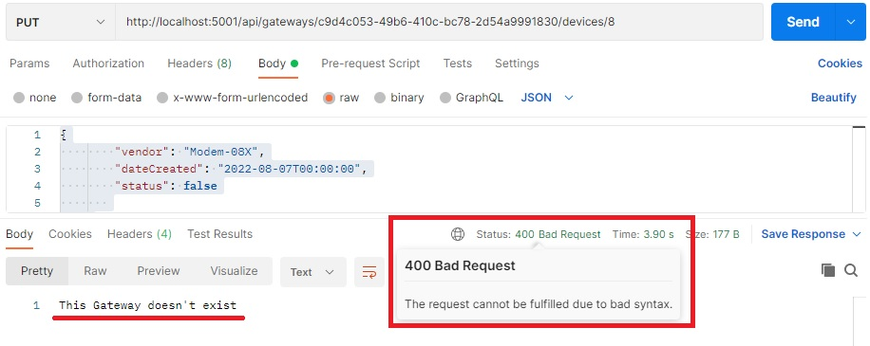

**Update Device (device doesn’t exist):** <http://localhost:5001/api/gateways/c9d4c053-49b6-410c-bc78-2d54a9991830/devices/90>

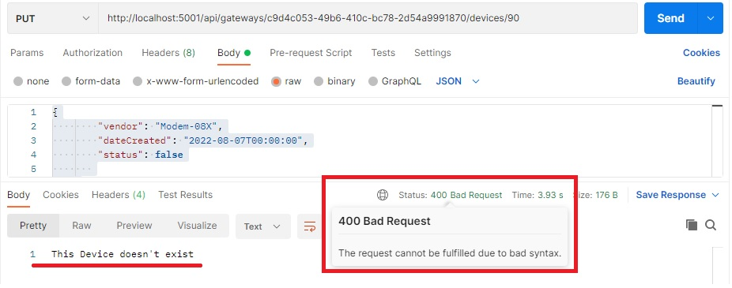

**Update Gateway:** <http://localhost:5001/api/gateways/8255F798-F6F8-4447-FAC3-08DA7A32EEDE>

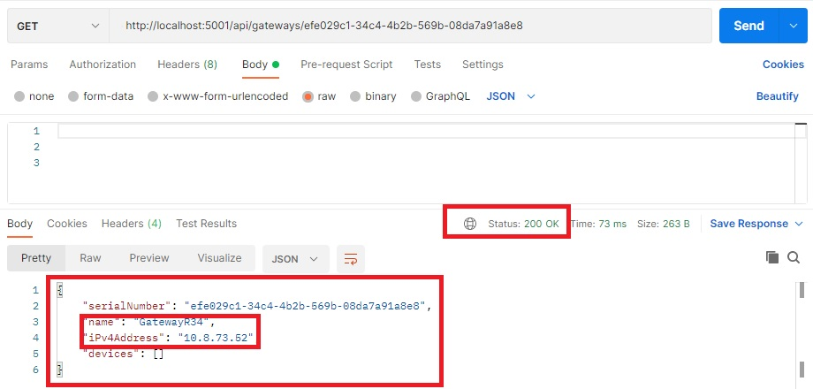

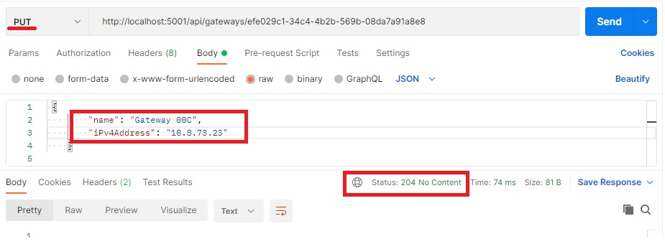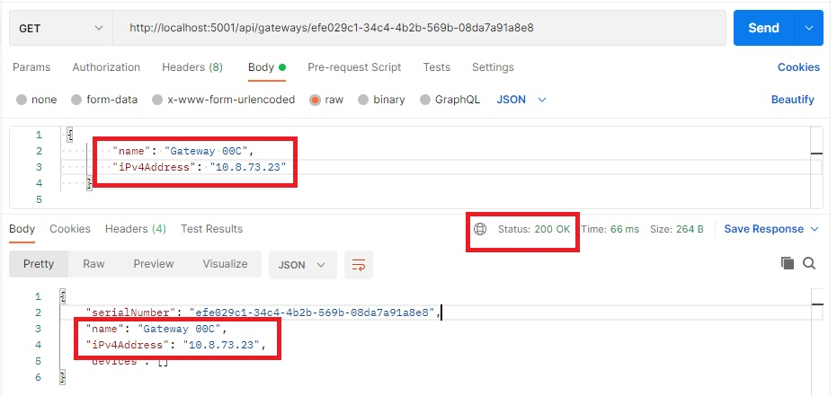

**Update Gateway (Gateway doesn’t exist):** <http://localhost:5001/api/gateways/00C0D27E-9032-4A58-87F1-08DA7B20E1E7>

*Body*

 {

        "name": "Gateway1",

        "iPv4Address": "10.8.77.120",

        "devices":null

    },

